** Question/Answer Booklet**

**Name:**

**PHYSICAL EDUCATION STUDIES YEAR 11 ATAR**

**Semester 1 Exam 2020**

**Time allowed for this paper**

Reading time before commencing work: 0 minutes

Working time for paper: 2 Hours

***To be provided by the candidate***

Standard items: pens (blue and black), pencils, eraser, correction fluid, ruler, highlighter

**Important note to candidates**

No other items may be taken into the examination room. It is **your** responsibility to ensure that you do not have any unauthorised notes or other items of a non-personal nature in the examination room. If you have any unauthorised material with you, hand it to the supervisor **before** reading any further.

**Structure of paper:**

|  |  |  |  |
| --- | --- | --- | --- |
| Section | Number of questions available | Number of questions to be attempted | Marks available |
| **Section One:**  Multiple-Choice | 20 | 20 | 20 |
| **Section Two:**  Short Answer | 15 | 15 | 60 |
| **Section Three:**  Extended Answer | 3 | 2 | 20 |
|  |  |  | **100** |

Answer the twenty **(20)** Multiple-Choice questions on the separate Multiple-Choice answer sheet provided.

**Multiple Choice (20 marks)**

1. There is approximately 100,000 kilometres of blood vessels, comprising of arteries, veins and capillaries in every adult athlete. Which of the following is **not** a characteristic of arteries?

(a) Carries blood away from the heart.

(b) Thick elastic walls permit continuous blood flow.

(c) Blood flow is created by the beating of the heart.

(d) Blood flow is created by the contraction of muscles.

1. The origin point for the hamstring muscle group is located on the:

(a) Pelvis.

(b) Femur.

(c) Tibia.

(d) Fibula.

1. The appendicular skeleton assists the human body to create movement. Which of the following bones are part of the appendicular skeleton:

(a) Ulna, Radius, Sternum.

(b) Humerus, Pelvis, Fibula.

(c) Femur, Metacarpals, Scapula.

(d) Tarsals, Phalanges, Coccyx.

1. In the action of kicking and making contact with a football, the leg and the agonist muscle group is the .
2. Extends, Gluteals.
3. Flexes, Quadriceps.
4. Flexes, Hamstrings.
5. Extends, Quadriceps.
6. Skeletal muscle tissue has many characteristics, which aid in the production of movement. In gymnastics, the ability for a muscle to stretch when a force is applied is critical to successfully performing choreographed routines. This is referred to as the muscles:

(a) Excitability.

(b) Contractibility.

(c) Extendibility.

(d) Elasticity.

1. General Motion is the most common form of motion in sporting activities and is best described as:

(a) Linear motion.

(b) Angular motion.

(c) A combination of linear and angular motion.

(d) The rotation around an axis.

1. Professional golfers know it is important for them to strike the ball as the club head is descending on the downswing. The application of maximal force when the club head makes contact with the surface of the golf ball just prior to reaching the bottom of the swing arc is an example of:

(a) Newton’s First Law of Motion.

(b) Newton’s Second Law of Motion.

(c) Newton’s Third Law of Motion.

(d) Newton’s Fourth Law of Motion.

1. Kyle Chalmers is the reigning Olympic Men’s 100m Freestyle gold medallist. In swimming his 100m event, Kyle increases his speed and then maintains this speed for as long as possible before eventually slowing down near or at the end of the race. When Kyle is maintaining his speed in the 100m, there is;

(a) Negative Acceleration.

(b) Positive Acceleration.

(c) Zero Acceleration.

(d) Constant Acceleration.

1. In netball, taller players often play in attacking and defending positions within the goal circle. Mid-court players will use a lob pass to clear a defending player in order to have the Goal Attacker (GA) or Goal Shooter (GS) receive the pass overhead. With this knowledge, which angle of projection would seem the most appropriate to perform a successfully lob pass?

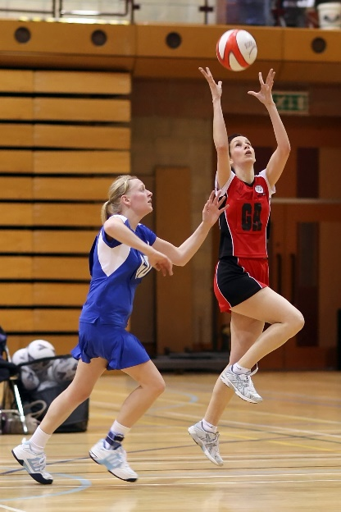

(a) 10 Degrees.

(b) 45 Degrees.

(c) 75 Degrees.

(d) 90 Degrees.

1. In a game of volleyball, players at the net defending will endeavour to ‘block’, jumping vertically before landing. By players bending their knees on landing, they reduce their chance of injury by increasing:

(a) Impulse.

 (b) Inertia.

(c) Momentum.

(d) Velocity.

1. Throwing a dart, as pictured below, can be classified as a:

(a) Discrete, Closed motor skill.

(b) Continuous, Open motor skill.

(c) Serial, Closed motor skill.

(d) Gross, Open motor skill.

1. Augmented feedback in which a coach provides information regarding the outcome or success of the movement to their athlete, is known as:
2. Specific feedback.
3. Knowledge of results.
4. Knowledge of performance.
5. Knowledge of feedback.
6. In an offensive play of NFL gridiron, the quarterback receives the ‘snap’ pass from the centre, then looks to throw the ball downfield to an eligible receiver who is covered by a defending player, the quarterback then decides to run with the ball himself. According to the information-processing model, what stage of the model did the quarterback reach?
7. Identification of stimuli/input.
8. Response identification/decision-making.
9. Response/output.
10. Feedback.
11. A ten-pin bowler who watches the ball spin and travel path down the lane before then hearing the ball strike into the pins is receiving:

1. Extrinsic feedback.
2. Augmented feedback.
3. Intrinsic feedback.
4. Knowledge of performance.

15. During an Inter-School basketball game, a coach shouts out to her players ‘zone defence’, as the ball is turned over from a rebound. This is an example of:

(a) Terminal feedback.

(b) Concurrent feedback.

(c) Constructive feedback.

(d) Intrinsic feedback.

16. Which of the following is not a characteristic of capillaries?

(a) Exchange carbon dioxide and oxygen.

(b) Have thin walls.

(c) Are microscopic.

(d) Have strong elastic walls.

17. Identify the joint movement performed by a swimmer’s shoulders during a backstroke race:

(a) Adduction.

(b) Flexion.

(c) Extension.

(d) Circumduction.

18. Which of the following statements about balance is TRUE?

(a) A lower centre of gravity and lower centre of mass decreases balance.

(b) A higher centre of gravity and higher centre of mass increases balance.

(c) A lower centre of mass and lower centre of gravity increases balance.

(d) A higher centre of mass and lower centre of gravity increases balance.

19. Sam’s swim coach calculates the average number of freestyle strokes she performs in a minute. This is a measure of Sam’s:

(a) Angular velocity.

(b) Angular acceleration.

(c) Angular speed.

(d) Angular distance.

20. Which of the following muscle groups are **not** antagonistic pairs?

1. Biceps, Triceps.
2. Trapezius, Deltoids.
3. Tibialis anterior, Gastrocnemius.
4. Gastrocnemius, Soleus.

**Short Answer (60 marks)**

This section has **Fifteen (15)** questions. Answer **all** questions. Write your answers in the spaces provided in this Question/Answer Booklet. Wherever possible, confine your answers to the line spaces provided. Use a blue or black pen (**not** pencil) for this section.

**Question 21 (5 marks)**

Identify the anatomical features within the right lung in the diagram below.

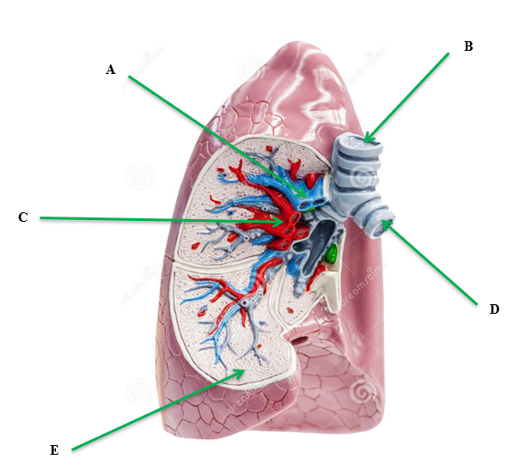

|  |
| --- |
|  |
|  |
|  |
|  |
| E. |

**Question 22 (3 marks)**

In the image below, identify the joint movement of the shoulder, elbow and wrist in pitching the baseball.

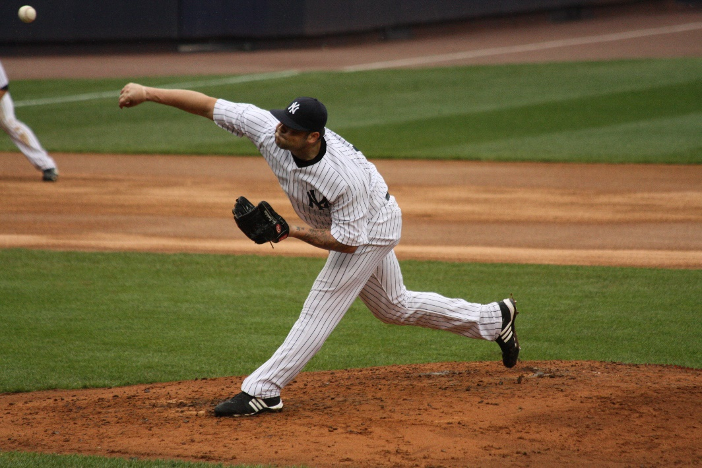

**Question 23 (4 marks)**

The body consists of three types of blood vessels: arteries, veins and capillaries. Compare and contrast **two (2)** characteristics of veins and arteries.

**Question 24 (6 marks)**

Identify the **muscles** A through to F on the diagram below. Answer in the space provided below.

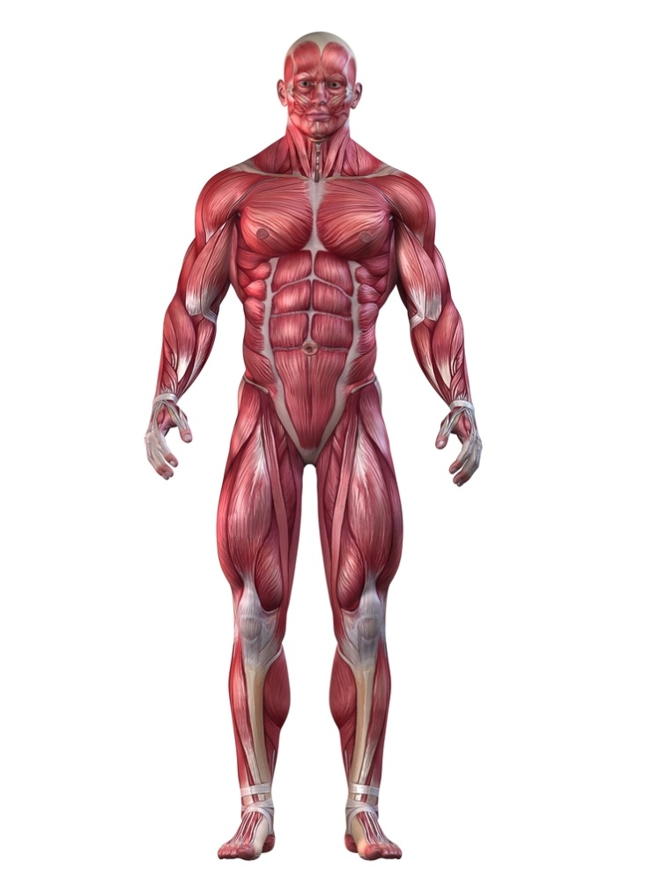

**A**

**B**

**C**

**D**

**E**

**F**

|  |  |  |
| --- | --- | --- |
| **A.** | **B.** | **C.** |
| **D.** | **E.** | **F.** |

**Question 25 (3 marks)**

Passing is a fundamental skill of netball. A successful shoulder pass often requires a player to throw the netball with high velocity. Explain how the use of sequential movement can achieve maximal speed in a successful shoulder pass.

**Question 26 (3 marks)**

Golf players use a variety of different clubs to ensure the golf ball travels the required distance. The angle on the club face affects the flight path and trajectory of the golf ball in the air. On the graph below, draw and label the three main trajectories a golf ball could make in its flight path in the air.

**Height**

**Distance**

**Question 27 (2 marks)**

To achieve maximum horizontal distance, a projectile should be released at a 45⁰ angle. Other than shot put, explain one sporting example where it is necessary to have an angle greater than 45⁰, and one example where it is necessary to have an angle less than 45⁰.

**Question 28 (3 marks)**

Define the terms positive, negative and zero acceleration and provide an example of each during a 200-metre freestyle swim.

**Question 29 (4 marks)**

Using examples, explain **two (2)** types of balance a gymnast may display during a floor routine.

**Question 30 (6 marks)**

Using specific examples, identify **three (3)** types of motion in the picture below.

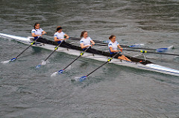

**Question 31 (2 marks)**

Athletes require multiple types of feedback to improve their performance. Explain the difference between internal and external feedback when performing a skill.

**Question 32 (4 marks)**

Identify the **bones** on the diagram below. Answer in the space provided.

**97**

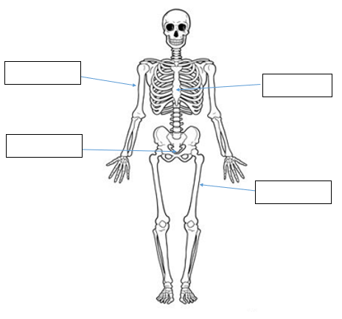

**Question 33 (4 marks)**

Western Australia’s Jackson Symonds of Sorrento SLSC claimed a record fifth Open Beach Sprint title at the 2019 National Surf Lifesaving Championships. Successfully winning sprint running races requires a fast start. Using your understanding of the information-processing model, explain how Jackson would successfully get a way to an explosive start in the sprint.

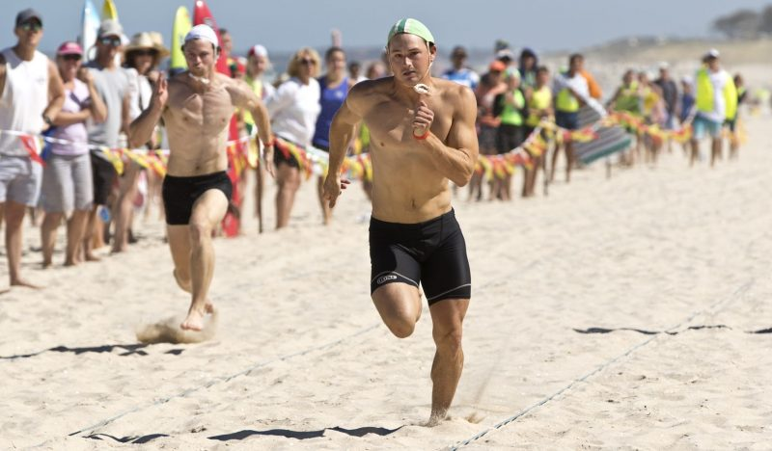

**Question 34**

**(4 marks)**

Cyclists in the Tour de France cycling race compete in teams and have support vehicles which provide nutrition, technical equipment and coaching support. Information on the race is also communicated via in-ear radio which provides feedback aiding in the potential success of the cycling team. Explain **two (2)** purposes of providing feedback to cyclists in such a race as the Tour de France.

**Question 35 (7 marks)**

Motor skills can be classified according to a number of different factors, including the amount of muscle involvement and the effects of the environment.

(a) Explain the difference between gross and fine motor skills and provide a volleyball example of each. (3 marks)

(b)(4 marks)

Place the following activities (A, B, C, D) on the continuum below.

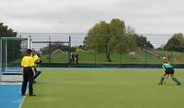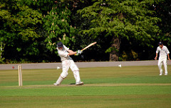

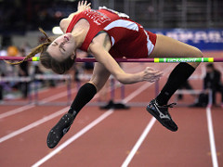

1. Cricket stroke **B**. Penalty stroke (green shirt)

**C**. High jump **D**. Surfing

**OPEN CLOSED**

**Extended Answer (20 marks)**

This section contains three (3) questions. **You must answer two (2) of these questions.** Write your answer in the spaces provided.

Spare pages are included at the end of this booklet. They can be used for planning your responses and/or additional space if required to continue an answer.

* Planning: if you use the spare pages for planning, indicate this clearly at the top of the page.
* Continuing an answer: If you need to use the space to continue an answer, indicate in the original space where the answer is continued, i.e. give the page number. Fill in the number of the question that you are continuing to answer at the top of the page.

**Question 36**

From the point of inhalation, describe the mechanics of breathing, including pressure change and flow of oxygen through the cardiorespiratory system to supply oxygen to the working muscle/s.

**Question 37 (10 marks)**

1. Using the three (3) athletes pictured below, discuss how the muscle fibre types

would vary for each athlete. In your answer, state each muscle fibre, include the

muscle fibre ratio of each.

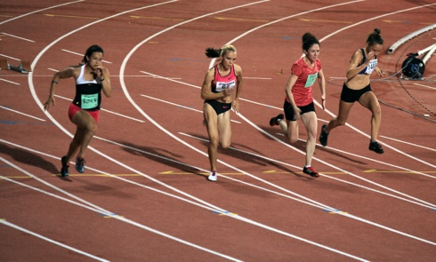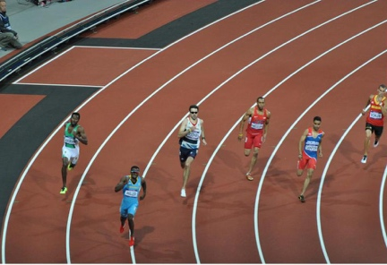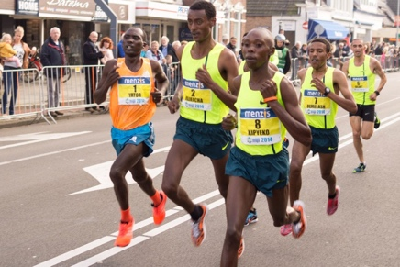

400m sprinter

Marathon runner

100m sprinter

(3 marks)

(b) Discuss how each of Newton’s three (3) Laws relate to the 100m sprint.

(7 marks)

**Question 38 (10 marks)**

The three golfers pictured below are in different phases of their golf career. The child pictured on the left is attempting to hit a golf ball for the first time, the recreational golfer pictured in the middle is working to improve his game, while the adult pictured to the right is playing in a professional tournament.

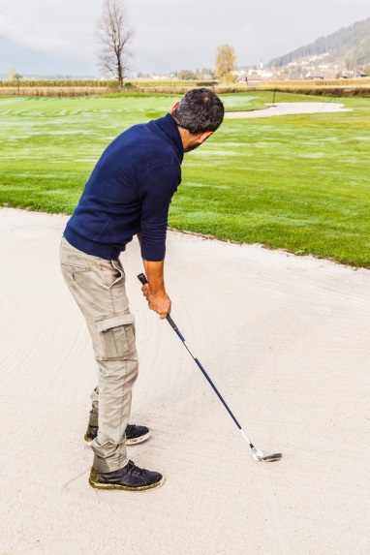

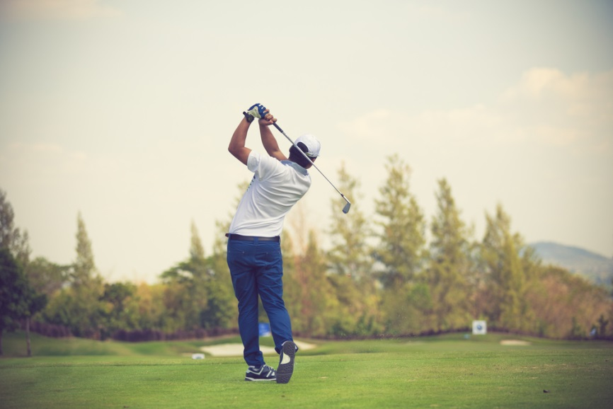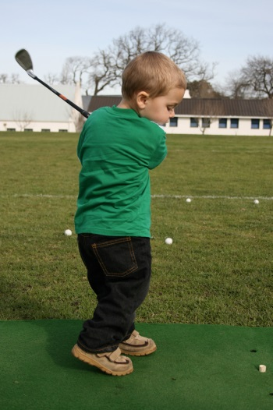

According to the Fitts and Posner model of skill learning, explain the three phases a golfer would move through as they progress from beginner level through to professional. In your response, identify the performance characteristics and type of feedback the learner would require in each phase to maximise their skill learning. Also identify the phase you would expect the golfer to spend the shortest amount of time in.

**End of paper**

**Additional Working Pages**

______________________________________________________________________